TLE Orbit Visibility Analysis

1. Introduction
This project presents a Python-based analysis framework for evaluating satellite visibility and ground-station coverage using publicly available Two-Line Element (TLE) orbital data. The objective of the analysis is to demonstrate how raw orbital elements can be transformed into operationally useful mission-analysis information such as satellite pass predictions, visibility statistics, and ground-track visualization.
Using a satellite database (sat_db_tle.txt), orbital propagation was performed with the SGP4 propagation model, which is the standard algorithm used for predicting satellite positions from TLE data. The analysis was conducted over the time window:
9 June 2025 00:00 UTC – 10 June 2025 00:00 UTC
for a ground station located at:
- Latitude: 48.123° N
- Longitude: 9.832° E
- Altitude: 250 m
The program processes TLE data and performs several tasks commonly used in space mission analysis and flight dynamics operations.:

Orbit Propagation
The software reads spacecraft TLEs and propagates their orbital states over the selected time interval using the SGP4 model. This allows satellite positions to be estimated throughout the analysis window.

Ground Station Pass Detection
For a given ground station location, the program determines when a satellite becomes visible above the horizon. For each detected pass, the following parameters are computed:
- Pass start time
- Pass end time
- Pass duration
- Time of maximum elevation (culmination)

Azimuth and Elevation Analysis
During each pass, the satellite's azimuth and elevation angles relative to the ground station are calculated. These quantities describe the satellite's apparent motion across the sky and allow generation of elevation-time and azimuth-time plots.

Ground Track Visualization
The subsatellite point (latitude and longitude of the satellite projection onto Earth) is computed during orbit propagation. These positions are used to produce ground-track plots, showing the satellite trajectory across the Earth's surface.

Multi-Satellite Analysis
The program can ingest a file containing multiple spacecraft TLEs and propagate each object individually, allowing analysis of constellation-level visibility and coverage.

Visible Satellite Count
For the specified ground station and time window, the program computes the number of satellites simultaneously visible above a given elevation mask and produces a time history of visible satellite counts.
To remove shallow horizon passes that are typically unusable for communication or observation, a minimum elevation mask of 10° was applied.
The analysis produced several outputs describing satellite visibility and orbital geometry relative to the ground station. These include satellite pass tables, elevation and azimuth profiles, ground-track visualizations, and statistics on the number of simultaneously visible satellites.

2. Results

2.1 Pass Predictions
The satellite propagation algorithm generated a pass table (passes.csv) describing all satellite passes over the ground station during the selected time interval.
Two cases were analyzed.

Case A — No Elevation Filter (min elevation = 0°)
Five satellite passes were detected during the 24-hour analysis period.
Pass | Start UTC | End UTC | Duration (s) | Duration (min) | Culmination UTC
1 | 2025-06-09T00:05:57 | 2025-06-09T00:13:47 | 469.7 | 7.83 | 2025-06-09T00:09:41
2 | 2025-06-09T01:42:27 | 2025-06-09T01:48:04 | 336.2 | 5.60 | 2025-06-09T01:45:11
3 | 2025-06-09T19:43:26 | 2025-06-09T19:47:59 | 273.1 | 4.55 | 2025-06-09T19:45:41
4 | 2025-06-09T21:16:45 | 2025-06-09T21:23:29 | 403.8 | 6.73 | 2025-06-09T21:20:02
5 | 2025-06-09T22:51:03 | 2025-06-09T22:58:07 | 423.4 | 7.06 | 2025-06-09T22:54:28

The detected passes lasted between 4.55 minutes and 7.83 minutes, which is typical for LEO satellites orbiting at altitudes of approximately 500–800 km.
These short visibility windows occur because LEO satellites travel at orbital velocities of approximately 7.5 km/s, causing them to traverse the sky quickly relative to the ground station.

Case B — Elevation Filter Applied (min elevation = 10°)
Applying a 10° elevation mask removes shallow horizon passes and retains only the higher-quality portions of each pass.

Pass | Start UTC | End UTC | Duration (s) | Duration (min) | Culmination UTC
1 | 2025-06-09T00:08:20 | 2025-06-09T00:11:07 | 166.7 | 2.78 | 2025-06-09T00:09:41
2 | 2025-06-09T21:19:05 | 2025-06-09T21:21:00 | 114.8 | 1.91 | 2025-06-09T21:20:02
3 | 2025-06-09T22:53:15 | 2025-06-09T22:55:44 | 148.8 | 2.48 | 2025-06-09T22:54:28
After filtering, three passes remain, with durations between 1.9 and 2.8 minutes.
These shorter durations occur because only the central high-elevation portion of each pass is considered.

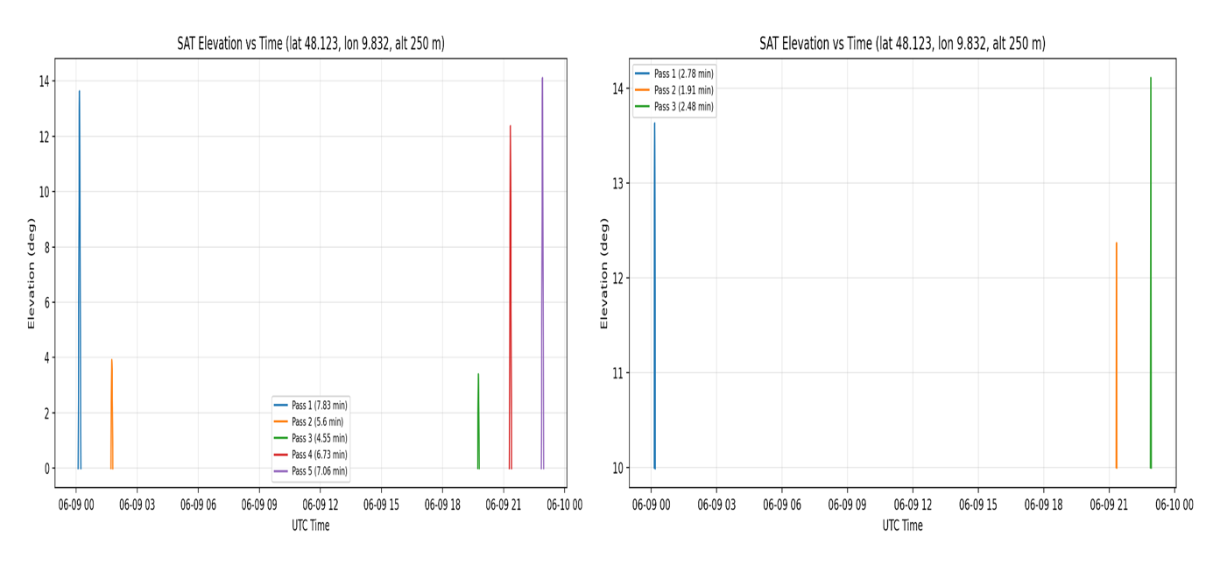
Figure 1. Elevation versus time for all satellite passes on 9 June 2025, observed from the ground station located at 48.123°N, 9.832°E with an altitude of 250 m.
The left panel shows results without applying an elevation cutoff, where five satellite passes are detected during the analysis window. These passes exhibit durations of approximately 4–8 minutes, which is typical for satellites in LEO.
The right panel shows results after applying a minimum elevation mask of 10°, which removes shallow horizon passes that are generally unsuitable for communication or observation. Under this constraint, only three passes remain, with durations reduced to approximately 2–3 minutes, since only the higher-elevation portion of each pass is considered.
The comparison demonstrates how applying an elevation mask reduces the number of usable passes and shortens their effective duration, which is an important consideration in practical ground-station operations.
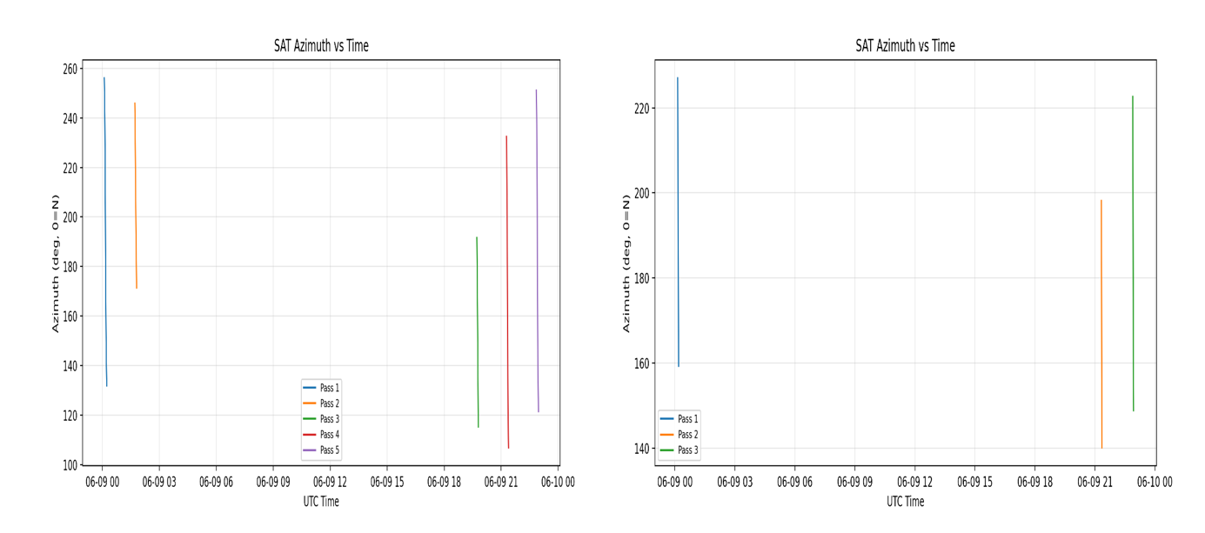Figure 2. Azimuth versus time for all satellite passes on 9 June 2025 observed at the ground station (48.123°N, 9.832°E, altitude 250 m).
Left: passes detected without an elevation cutoff (5 passes, azimuth ranging approximately 130°–260°).
Right: passes detected with a 10° elevation cutoff, resulting in three visible passes.
The azimuth tracks correspond to the same events seen in the elevation plots, showing the satellite moving from southeast to southwest during each visible pass. Applying the elevation filter reduces the number of plotted arcs but does not alter the overall azimuth geometry.
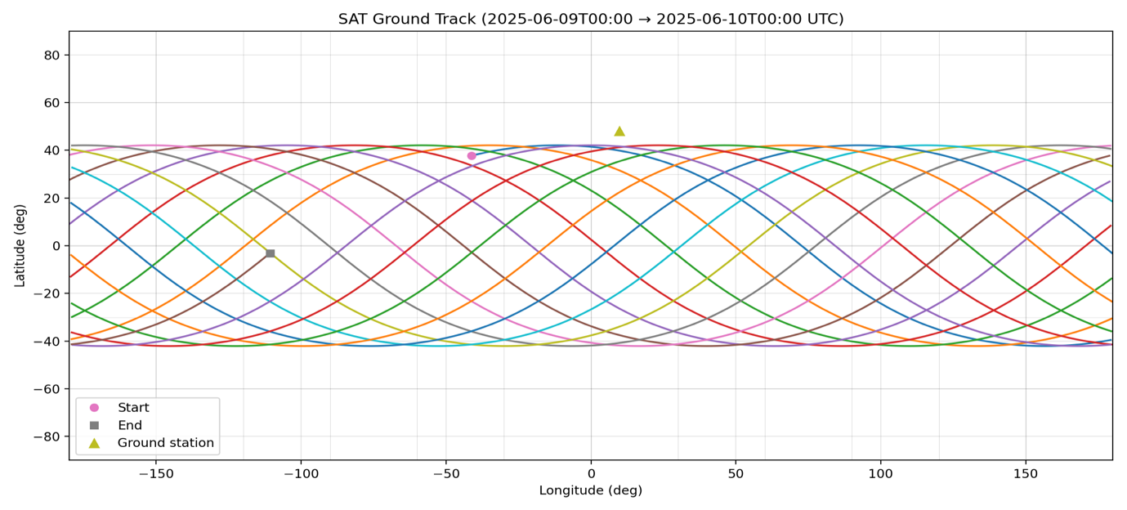Figure 3. Ground track of the satellite between 2025-06-09 00:00 UTC and 2025-06-10 00:00 UTC.
The track consists of coloured arcs representing consecutive orbital revolutions projected onto Earth's surface. The characteristic wave-like pattern is typical for a Low Earth Orbit satellite.
The starting point (pink dot), ending point (grey square), and the ground station (yellow triangle) at latitude 48.123°N and longitude 9.832°E are annotated.
The ground track is confined to approximately ~ 42° latitude, while the westward shift between successive passes results from Earth’s rotation beneath the orbit.

2.2 Satellite Visibility Over Time
Using the full satellite database (sat_db_tle.txt), the number of satellites simultaneously visible from the ground station was calculated.
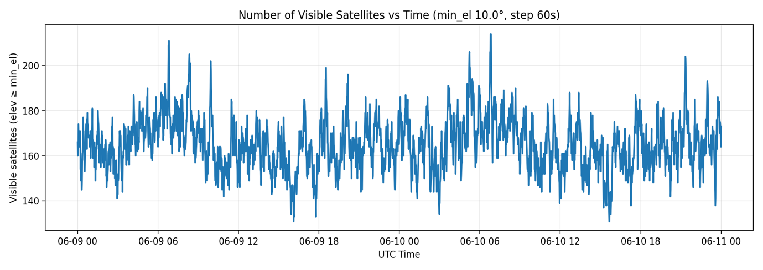
Figure 4. Number of visible satellites over time for a ground station located at 48.123°N, 9.832°E, using a 10° minimum elevation mask and a 60-second time step.
The plot shows that approximately 140 to 220 satellites are simultaneously visible during the analysis window (9–11 June 2025). This large number reflects the presence of modern dense Low Earth Orbit (LEO) constellations, particularly broadband communication systems such as Starlink, along with other operational spacecraft contained within the TLE database.
The number of visible satellites varies over time due to several orbital-dynamics factors, including:
• orbital plane spacing
• inclination distribution
• satellite phasing within constellations
• Earth’s rotation relative to the orbital planes
Peaks in the visibility curve occur when multiple orbital planes pass over the ground station simultaneously, while lower counts correspond to periods when fewer satellites occupy geometrically favorable positions relative to the observer..

3. Discussion
The results demonstrate how satellite visibility is strongly influenced by orbital geometry, ground station location, and constellation density.
The pass prediction analysis confirms that individual LEO satellites typically produce short visibility windows lasting approximately 5–8 minutes, consistent with their high orbital velocities. When a minimum elevation mask is applied, only the central portions of the pass remain visible, reducing effective pass durations to roughly 2 minutes.
The constellation visibility analysis reveals that the modern Low Earth Orbit environment is extremely crowded. The observation that 140–220 satellites can be visible simultaneously highlights the rapid expansion of large commercial constellations.
Temporal variations in satellite visibility arise from the combined effects of:
- orbital plane distribution
- inclination diversity
- satellite phasing
- Earth's rotation relative to the orbital planes
Ground-track visualizations further illustrate how satellites sweep across Earth's surface in repeating patterns as the planet rotates beneath their orbital planes.
A comparison between satellites with different orbital inclinations also demonstrates how inclination affects ground coverage. Mid-inclination satellites, such as the ISS, remain confined to limited latitude bands, whereas near-polar satellites, such as NOAA-19, generate near north-south ground tracks and provide broader global coverage with frequent high-latitude revisits.
Overall, the analysis confirms that TLE-based propagation combined with pass prediction and visibility analysis provides an effective approach for evaluating ground station coverage and satellite constellation density.

4. Conclusion
This study demonstrated how publicly available TLE orbital data can be used to analyze satellite visibility, predict ground-station passes, and evaluate constellation density using standard astrodynamics techniques.
The results show that individual LEO satellites produce short visibility windows of several minutes, while modern satellite constellations ensure that large numbers of satellites are simultaneously visible from a single ground location.
Such analyses are essential for ground station scheduling, communication planning, and understanding the rapidly increasing density of spacecraft in Low Earth Orbit.

Appendix A- Multiple TLE Analysis -Example
Running the case for ISS (ZARYA) and NOAA-19

ISS (ZARYA)
1 25544U 98067A | 25274.51094907 | 0.00014338 | 00000-0 | 25920-3 | 0 | 9990
2 25544 51.6437 | 353.0325 0005282 | 64.4153 | 61.2595 | 15.4977855 | 48 | 127
NOAA 19
1 33591U 09005A | 25274.21375483 | 0.00000079 | 00000-0 | 72657-4 | 0 | 9998
2 33591 99.1967 | 289.2420 0014225 | 64.2102 | 296.0701 | 14.1250898 | 579 | 9354

1. Pass Predictions
ISS (ZARYA)
sat | pass | start_utc | end_utc | duration_s | duration_min | culmination_utc
ISS_ZARYA | 1 | 2025-06-09T01:18:38.791317Z | 2025-06-09T01:25:14.621960Z | 395.8 | 6.6 | 2025-06-09T01:21:56.475942Z
ISS_ZARYA | 2 | 2025-06-09T02:55:46.081697Z | 2025-06-09T03:02:37.100108Z | 411.0 | 6.85 | 2025-06-09T02:59:11.692411Z
ISS_ZARYA | 3 | 2025-06-09T04:33:00.495837Z | 2025-06-09T04:38:52.540759Z | 352.0 | 5.87 | 2025-06-09T04:35:56.644268Z
ISS_ZARYA | 4 | 2025-06-09T21:20:41.396620Z | 2025-06-09T21:25:13.861648Z | 272.5 | 4.54 | 2025-06-09T21:22:57.235071Z
ISS_ZARYA | 5 | 2025-06-09T22:56:05.905301Z | 2025-06-09T23:02:55.019275Z | 409.1 | 6.82 | 2025-06-09T22:59:29.663680Z

- Five passes above the ground station were recorded within the 24-hour window.
- Pass durations ranged between 4.5 and 6.8 minutes, typical for ISS overpasses.
- The maximum elevations were very high, nearly reaching 70–80°, meaning the ISS was passing nearly overhead.

NOAA-19
sat | pass | start_utc | end_utc | duration_s | duration_min | culmination_utc
NOAA_19 | 1 | 2025-06-09T04:36:33.319305Z | 2025-06-09T04:42:45.204635Z | 371.9 | 6.2 | 2025-06-09T04:39:39.442214Z
NOAA_19 | 2 | 2025-06-09T06:15:29.650735Z | 2025-06-09T06:26:35.402747Z | 665.8 | 11.1 | 2025-06-09T06:21:02.885701Z
NOAA_19 | 3 | 2025-06-09T07:57:29.208007Z | 2025-06-09T08:04:26.751266Z | 417.5 | 6.96 | 2025-06-09T08:00:57.875191Z
NOAA_19 | 4 | 2025-06-09T16:05:32.364764Z | 2025-06-09T16:15:40.171566Z | 607.8 | 10.13 | 2025-06-09T16:10:35.129084Z
NOAA_19 | 5 | 2025-06-09T17:46:22.938504Z | 2025-06-09T17:56:16.111548Z | 593.2 | 9.89 | 2025-06-09T17:51:17.888342Z

- Five passes were also given in the same window.
- Pass durations varied more widely, ranging between 6 and 11 minutes, which was reflective of its sun-synchronous polar orbit.
- Maximum elevations reached nearly 90° (direct overhead), confirming strong visibility.

2. Elevation vs Time Plots

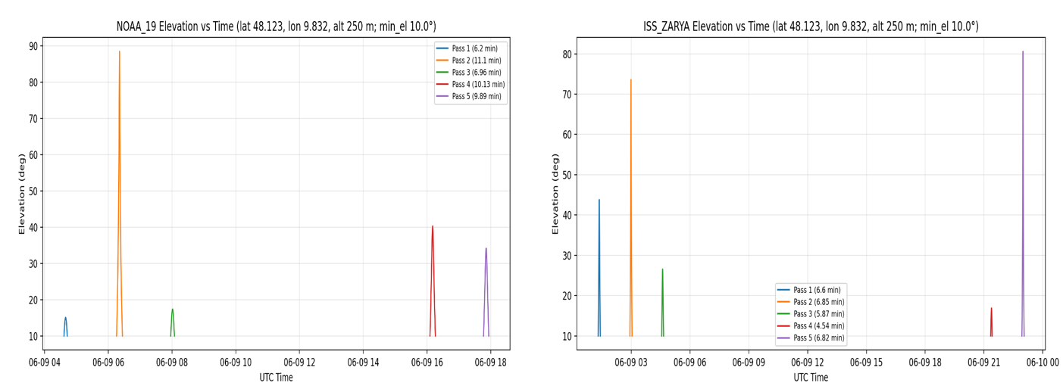
Figure 5: Shows elevation against time for NOAA-19 (left) and ISS (ZARYA) (right) passes over the ground station (48.123°N, 9.832°E, 250 m) during 9 June 2025. NOAA-19 generated five passes attaining maximum elevations of nearly 90° and durations up to 11 minutes as expected for a polar sun-synchronous orbit. Likewise, the ISS ZARYA generated five passes, with maximum elevations of ~80° and durations from 4.5 to 6.8 minutes, as is to be expected from a mid-inclination orbit. The comparison clearly brings out the orbital geometry dependence of pass frequency, highest elevation, and visibility duration.
- ISS: More frequent passes distributed over different times, with some passes nearly overhead.
- NOAA-19: Passes are more spread out during the course of the day with very steep elevation peaks.
- The elevation plots explain the coverage as a function of orbital inclination: While ISS at ~51.6° inclination delivers mid-latitude arcs, while NOAA-19 (~99° inclination) delivers near-polar coverage and longer visible arcs.

3. Azimuth vs Time Plots
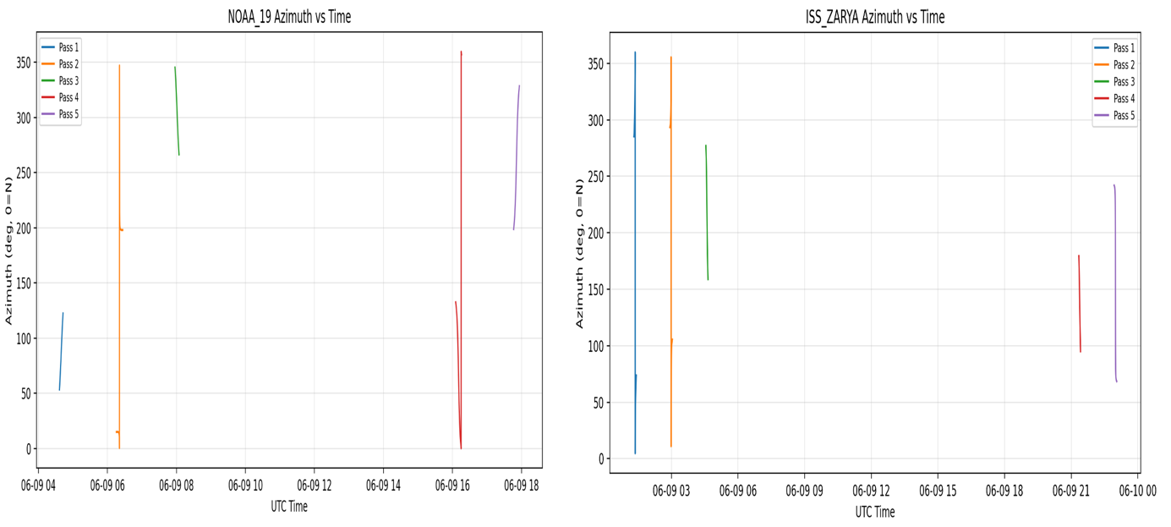
Figure 6: Azimuth against time on 9 June 2025 for NOAA-19 (left) and ISS ZARYA (right) passes above the ground station (48.123°N, 9.832°E, 250 m. NOAA-19 pass shows strong north–south azimuth sweeps consistent with almost polar orbit, whereas those of ISS ZARYA are mid-latitude azimuth sweeps with its 51.6° inclination. Each curve corresponds to a distinct pass and thus corresponds to an elevation plots.
- ISS: the wide range of Azimuth sweeps by the ISS as it passes arise from low horizons to a low end setting in almost opposite directions of azimuth, consistent with orientation of the inclined orbit.
- NOAA-19: as with a nearly polar pass, tracks show strong N–S azimuth sweeps.

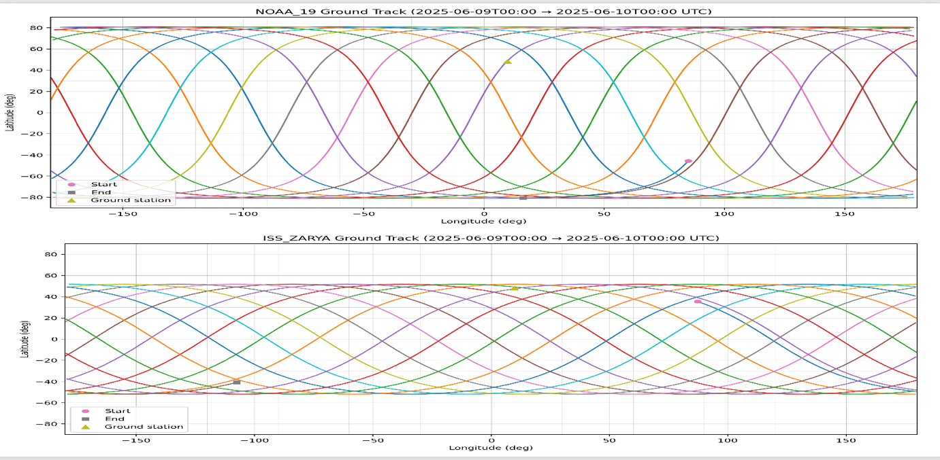
4. Ground Track Visualizations
Figure 7 : Ground tracks of NOAA-19 (a) and ISS ZARYA (bottom) from 2025-06-09 00:00 UTC to 2025-06-10 00:00 UTC. NOAA-19 covers near pole-to-pole, hence the high-elevation opportunities, while ISS ZARYA should stay within ±51° in latitude, offering frequent but mid-inclination coverage. Start (pink dot), end (grey square), and the ground station (yellow triangle) are annotated for reference.

- ISS: The ground track gives very dense coverage between ±51° latitude, parallel its orbital inclination. The ground station (48.1°N) lies near the edge of this band, giving it several strong passes.
- NOAA-19: The track covers near pole-to-pole movements because of the ~99° sun-synchronous orbit, ensuring that it gets to have near-zenith passes over the station multiple times a day.

Summary
By consuming multiple TLEs in a single run:
- The program has now been designed to operate on various satellites simultaneously, storing results (passes, plots, ground tracks) per satellite.
- Some clear results show the contrast between a mid-inclination orbit (ISS) and a polar orbit (NOAA-19): ISS provides short passes frequently at varying elevation angles, while NOAA-19 delivers high-elevation, polar-spanning passes of longer duration.
- This establishes a case for scalability of the pipeline for constellation or multi-mission analysis, where coverage of different satellites could be compared side-by-side.

